Mister ED’s Heiken Ashi 4 hour system

This is as close to a purely mechanical system that I can get. The aim is to reduce any subjective trading decisions and trade based on previous performance. The system allows profit and stop loss targets to be continually altered by using the average true range (ATR20) for the previous 20 trading days (one month) and therefore adjusts to the volatility of the market. The HA indicator does occasionally repaint but I have not found this to be a significant problem since trading this live for the past 18 months.

This is a system that I have put together from looking at many other systems and therefore I am not really the author of this system, just the collator of information.

Anyone using this system must do so having tested it thoroughly as I have done over a long period and must do it at their own risk. I have therefore not published some of the performance figures that I have derived this system from that is up to the individual trader to calculate for themselves.

The system has been developed using the following pairs:

GBPJPY
GBPUSD
EURJPY
EURUSD
USDCAD
EURGBP
AUDUSD
AUDJPY
NZDUSD
USDJPY
Gold

It can be used on all types of markets but I have limited it to these pairs to make it manageable. I am trading it on MT4 using charts from Metatrader and FXDD (for Gold).
These use a GMT+1 candle. I have not used the system on other time scales successfully and so can offer no guidance in this respect.

Chart set up

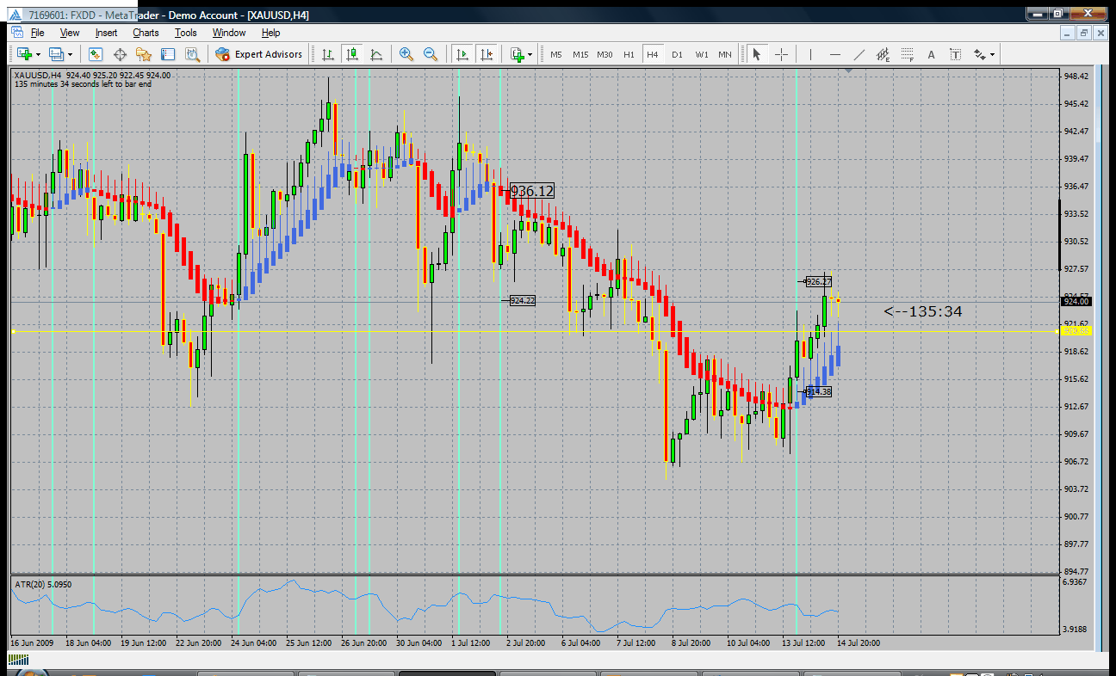

Light blue vertical lines show potential entry points, figures in boxes show take profit 1 (TP1) and initial stop loss (SL) for some of the trades. The horizontal yellow line is the trailing stop that I have drawn in place and should be moved to about 921.70 if using the wick top trailing stop loss (TSL)(see later).

Indicators

HA Smoothed
Settings 2,6,3,2
ATR – 20
4 hour chart

Entry

Standard
- wait for the HA signal to change colour completely from blue to red (or vice versa). The whole candle must change so that the body and the wick are the same colour.
- Measure the ATR and the candle length (body and wick) on the signal candle.
- If the signal candle is between 50% and 200% of the ATR value for that candle then it is a valid trade. If the signal candle is less than 50% then no trade. If the signal candle is more than 200% then use a retrace entry (see below).

Retrace
- if the signal candle (body and wick) is larger than 200% of the ATR then draw a fib retracement on the signal candle
- wait for a the price to retrace at least 32% and place an entry order at the high (if going long) or low (if short) of the signal candle
- The TP1 and SL are calculated from this entry point as normal

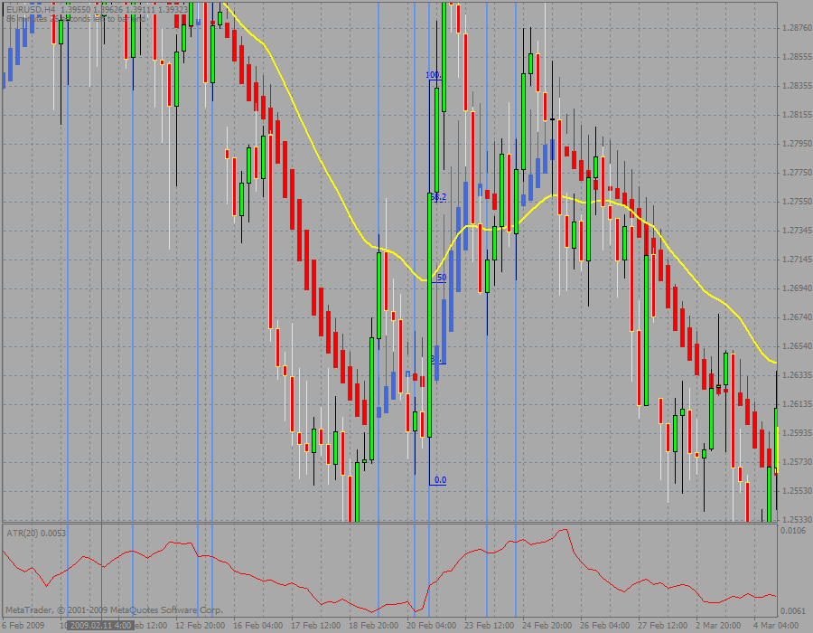

Eg signal candle at 20 Feb 16:00 is 282 pips. ATR is 76, 200% of ATR is 154. Therefore draw a fib, wait until the price retraces by 32% (1.2754) then place an order at the top of the signal bar (1.2838) and target ATR (1.2914) for TP1
N.B. this is a massive signal candle and will leave the HA bars far behind, therefore it may be wiser to bring the trailing SL much closer than using the HA bars.

Stop Loss
- the stop loss is calculated as the ATR value on the signal candle
- SL therefore is never larger than TP1

Closure
- TP 1 is the ATR.
- Once TP1 has been reached bring the SL up to the top of the HA body and trail the stop with each new candle (TSL).
- Trailing this way allows the trade room to move and reduces the trade being stopped out prematurely (see variations below)

Money management

The trade should risk only 3% of the trading account in each trade. This means that if all 11 pairs were to give simultaneous signals 1/3 of the account would be at risk. This is not advisable and has not happened in the last 2 years that I have traded this system. The maximum has been 9 trades simultaneously, but the average is 2.6 trades.

If multiple simultaneous trades are indicated then it is best to reduce the risk on all the trades rather than be selective on which ones are taken. This is because the system is mechanical and incorrect trade choices can be made if you are selective. (See optimisation – below)

Optimisation, record keeping, and variations

There are several areas in which I have optimised the return on this system. The system has been back tested manually over thirty years of data on various pairs and has never produced a negative annual return.

I have recorded the performance over the last 2 years of most of the pairs and have found that there are times when certain trades are more likely to fail and therefore I have customised the system so that I will not trade certain pairs on certain days.

Some pairs do not perform at all well on certain days and so I will just ignore any set ups on these days. Some pairs perform better earlier of later in the day, however I have chosen to ignore this filter in my trades at the moment. I run 2 databases of results, one where I record every trade setup as it occurs on all the pairs, and one where I just have my optimised trades. I compare these results every day to see if things have changed and any alterations are required.

These are the current optimisation setups (NB these will change over time and are not fixed, they must be altered and monitored all the time by the trader)

GBPJPY - trade every day
GBPUSD - trade only Monday, Tuesday
EURJPY - trade Monday, Wednesday, Thursday, Friday
EURUSD - trade Monday, Tuesday, Thursday, Friday
USDCAD - trade Monday, Friday
EURGBP - trade every day
AUDUSD - trade just Monday
AUDJPY - trade every day
NZDUSD - trade Monday, Friday
USDJPY - trade every day
Gold - trade Monday, Tuesday, Thursday, Friday

This restriction in trading does reduce the number of trades but it significantly improves the performance. Strike rates for this year range from 100% to 65% for the above pairs. Win : loss ratios for the pairs range from 1.04:1 to 1.51:1 (and AUDUSD where there have been no losing trades this year so far, but only 10 trade set ups).
This optimisation has given me 31603 pips for the year from 92 win days, 32 loss days and 15 no-trade days. I average 216 pips a day overall with 409 pip average on a win day and -188 pips on a loss day.

Some pairs are more profitable if everything is taken off at TP1, others do better if half is taken at TP1 and the remaining 50% left to ride the trailing stop loss. That is for the individual trader to decide and must be done by back and forward testing.

Further optimisation that can be done is to use the top of the wick as the TSL if the trade has moved quickly away from the HA bars, or to just manually close things up if you encounter a really long candle.

It is important to be able to take all the trades that are on offer as all the statistical calculations are based on the complete set of trades. If you try to be selective the system usually starts under performing. The aim is that this is a purely mechanical system.

I am sure that further optimisation can be made but this is up to the trader to do based on his/her own back testing and due diligence. I am not going to show my database results as I believe that any trader using this system must do their testing themselves to understand how the system works and how they want to manipulate the system to their advantage. I have tried many other systems only to find they didn’t work in my hands when I tried them for real. Therefore I have given the system and it is up to the person using it to learn how it works so that they too can trust it.

I hope this is helpful to you all,

Mister ED

YOU MUST TEST THE SYSTEM THOROUGHLY BEFORE USING IT LIVE!

